

Budapest University of Technology and Economics

Faculty of Electrical Engineering and Informatics

Imed Mahmoudi

SUPERVISOR

BUDAPEST, 2017

Contents

Summary 6

Sommaire 7

1 Introduction 8

1.1 Solar power basics 8

1.1.1 Operation of a PV panel 8

1.1.2 Electrical characteristics 8

1.1.3 Solar panel used in our project & it's characteristics 8

1.2 USB charger 8

1.2.1 USB charging modes 8

1.2.2 USB charger detection 8

1.3 Power electronics basics 8

1.3.1 Switch Mode Power Supply basics 8

1.3.2 Power switches 8

1.3.3 Non-isolated DC/DC converter topology analyses 8

2 Functional requirements 10

3 System design and simulation 10

References 11

Annex 12

STUDENT DECLARATION

I, **Imed Mahmoudi**, the undersigned, hereby declare that the present MSc thesis work has been prepared by myself and without any unauthorized help or assistance. Only the specified sources (references, tools, etc.) were used. All parts taken from other sources word by word, or after rephrasing but with identical meaning, were unambiguously identified with explicit reference to the sources utilized.

I authorize the Faculty of Electrical Engineering and Informatics of the Budapest University of Technology and Economics to publish the principal data of the thesis work (author's name, title, abstracts in English and in a second language, year of preparation, supervisor's name, etc.) in a searchable, public, electronic and online database and to publish the full text of the thesis work on the internal network of the university (this may include access by authenticated outside users). I declare that the submitted hardcopy of the thesis work and its electronic version are identical.

Full text of thesis works classified upon the decision of the Dean will be published after a period of three years.

Budapest, 26 November 2017

...…………………………………………….

Summary

The text of an English language ½-1 page long summary goes here. This summary has to be also uploaded to the Thesis Portal separately.

Sommaire

The text of a ½-1 page long summary goes here in a second language, different of English (German, French, Portuguese, Russian, Finnish, Korean, Chinese, Japanese, Hungarian, etc,). This summary is the translation of the summary in English and has to be also uploaded to the Thesis Portal separately.

# Certainly, the human lifestyle is developing day by day through the technological development which provoque the growth of needs of energy supply for the world population, this is the way various sources of energy exist to answer these needs. Nowadays, most of used sources of energy are of not renewable origin, that are existing in limited quantities compared with the energy consumption according to the human scale. Also these sources are fossile energies (oil, coal, gas) coming from the grounded earth and requiring thousands of years to be produced or renewed.

Where from the world of researches aims towards the development of the renewable energies that are naturaly renewal and their sources are not epuisable on the scale of human timeand humain consumption.

These sources are based on natural unlimited emission of energy like solar, wind, hydraulic, geothermal energies, navy and the biomass.

The most powerful renewable source of energy is the sun, which thanks to its radiation, with average over the entire earth of 164 Watts per square meter over a 24 hour day, the power that can be produced is really infinit power.

**1.1 Solar power basic**

**Solar energy:** is an important source of [renewable energy](https://en.wikipedia.org/wiki/Renewable_energy) this method is energy derived from the sun by extracting the radiant light and heat from the [Sun](https://en.wikipedia.org/wiki/Sun) that is harnessed using a range of ever-evolving technologies like:

**Photovoltaics:** is a term which covers the conversion of light into [electricity](https://en.wikipedia.org/wiki/Electricity) using  [semiconducting materials](https://en.wikipedia.org/wiki/Semiconducting_material) that exhibit the [photovoltaic effect](https://en.wikipedia.org/wiki/Photovoltaic_effect)

**Solar thermal collector:** collects [heat](https://en.wikipedia.org/wiki/Heat) by [absorbing](https://en.wikipedia.org/wiki/Absorption_(optics)) [sunlight](https://en.wikipedia.org/wiki/Sunlight) and use it for heating fluid (air, antifreeze or water) this technique exist in different form the : flat collector , tubes collectors or dish collector.

Advantages:

**It’s a renewable resource** Solar energy is a renewable source of energy as it can be used to produce electricity as long as the sun exists. Sunshine occurs naturally. As long as we are alive, we are always going to see the sun, which means it is infinite.

**pollution:** Solar energy is an alternative for [fossil fuels](http://www.conserve-energy-future.com/various-fossil-fuels-facts.php) as it is non-polluting, clean, reliable and renewable source of energy. It does not [pollute the air](http://www.conserve-energy-future.com/causes-effects-solutions-of-air-pollution.php) by releasing harmful gases like carbon dioxide, nitrogen oxide or sulphure oxide

**1.1.1 Operation of a PV "Photovoltaics" panel**

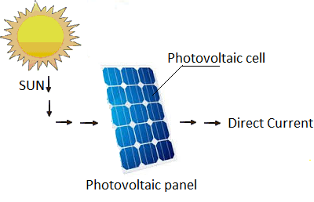A photovoltaic solar panel having for role the conversion of light received by the sun to electricity.

This panel is a consists of a set of many photovoltaic cells connected in series.

The photovoltaic cell :  is an electrical device that converts the energy of [light](https://en.wikipedia.org/wiki/Light) directly into [electricity](https://en.wikipedia.org/wiki/Electricity) by the [photovoltaic effect](https://en.wikipedia.org/wiki/Photovoltaic_effect), which is a [physical](https://en.wikipedia.org/wiki/Physics) and [chemical](https://en.wikipedia.org/wiki/Chemical_substance) phenomenon.

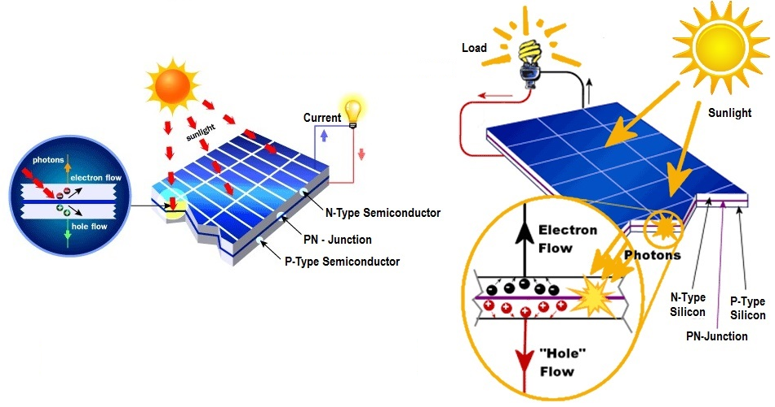 Figure1: Basic operating principal of a photovoltaic cell

The operation of a photovoltaic cell requires three basic attributes:

* The absorption of light, generating either [electron](https://en.wikipedia.org/wiki/Electron)-[hole](https://en.wikipedia.org/wiki/Electron_hole) pairs or [excitons](https://en.wikipedia.org/wiki/Exciton" \o "Exciton).
* The separation of charge carriers of opposite types.
* The separate extraction of those carriers to an external circuit.

**1.1.2 Electrical characteristics**

As it is mentionned before a photovoltaic panel consists of a set of photovoltaic cells. In the presence of sun, each of these cells produces a current I (in ampere A) and a tension U (in volt V). The product of these 2 sizes gives a power P, expressed in Watt (W).

And in these next figures what athe electric characterstic of a solar pannel looks like:

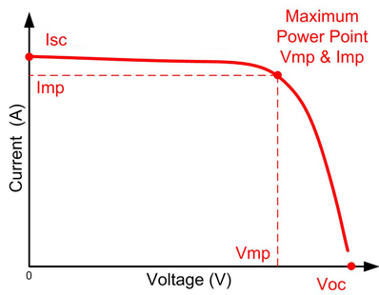

Figure2: produced Current-tension curve

 Voc: tension opened circuit indicates the present tension in the borders of the panel when he is not connected.  
Isc: current of short circuit indicates the current max that the panel can free..

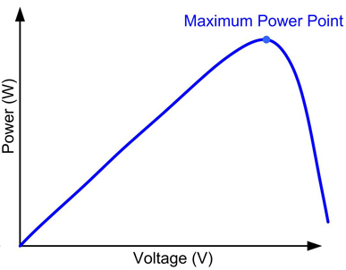

Figure3: Power produced curve

The Point of Maximum Power on this curve corresponds to the product of 2 particular values which are:  
- The current of maximal power noted Impp (or Ippm)  
- The tension of maximal power noted Vmpp (or Vppm)

**1.1.3 Solar panel used in our project & it's characteristics:**

# 1.2 USB charger:

**Universal Serial Bus:** is a standard relative to an IT bus in serial transmission which serves to connect computing peripherals to a computer or to every type of device planned for that purpose (tablet, smartphone). The USB bus allows to connect peripherals to the computer is underway and benefiting from Plug and Play which recognizes automatically the devises

**USB power supply:** has for characteristic to supply devises with energy to charge it's battery. it uses for it a cable compound of four pins for the USB 1 and 2 (the mass GND, the feeding VBUS and two pins of data called D- and D +).

The pins D+ and D- forms a twisted pair and use the principle of the differential transmission of data between the two devices connected through the USB port.

In almost every case in a USB charging network, there is one host and one device. generally our PC or charger is always the host, and your Smartphone, tablet, or camera is the device.

Power always flows from the host to the device, although data can flow in both directions in use of USB

**USB 2.0 VS USB3.0:** usb ports exist in different categories and type with different number of connectors and different [communications protocols](https://en.wikipedia.org/wiki/Communications_protocol) for connection, communtion, and different power supply between [computers](https://en.wikipedia.org/wiki/Computer" \o "Computer) and devices.

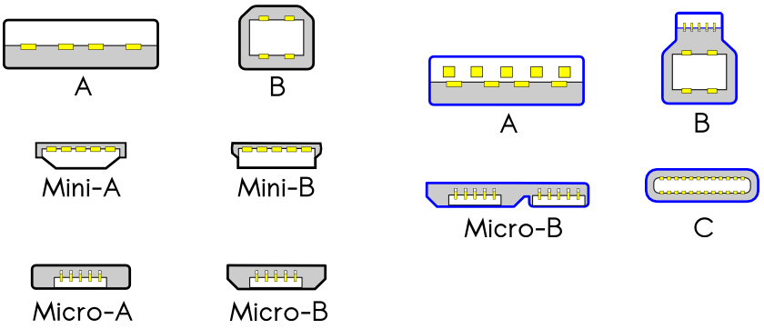

Figure4: Different type of USB connectors

The most common and used USB are the USB type A 2.0 and A3.0 but there is a wide range of difference between these two ports.

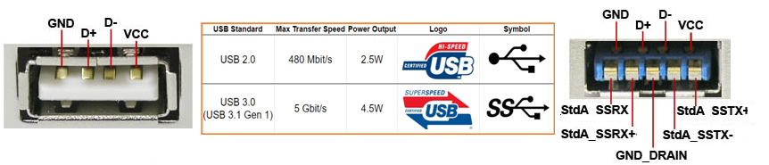The USB 2.0 port has four pins, and it's USB cable contain four wires. The inside pins carry data (D+ and D-), and the outside pins provide a 5-volt power supply and GND pin. While USB 3.0 ports add an additional row of five pins, so its connection cables have nine wires.Also in terms usb charging port. The USB 2.0 port is capable of delivering up to 500mA (0.5A); with USB 3.0, it moves up to 900mA (0.9A). and in FAST charging downstream and it provide up to 1,500mA (1.5A).

Figure5: Differences between USB type A 2.0 and A3.0

**1.2.1 USB charging Modes:**

We have already spoken about the load in USB, a more and more current thing. Let us explain the various modes which exist to load a mobile device with an USB port.

In the first place, there is a basic charger, which supplies only the electric current. The standard is simple: it is 100 mA at the most and there is no signal of data. This cheap chargers generally have no signal in question and certain telephones block the load and data exchange and they consider that they are going to receive only 100 mA, what is too little for a load(responsibility), even if the charger supplies more.

Then, there is a "intelligent" charger, which supplies 500 mA and warns the devise that it is going to exchange electric current , via the lines of data. It is the case of the majority of leading chargers.

There are several modes, but we stay globally in two cases and we are intereseted in the intelligent mode.

# Last operations and checks

Once the content is ready, you should not forget the following operations:

* Update cross-references: select all the text first (Ctrl+A) and then press F9 to let the Word to update all cross-references. A check for “Error!..” at the places of references should be carried out.
* Specify document properties: you need to specify all necessary meta-data for the document such as the author, title, keywords, etc. The Document property panel appears if the File / Info / Document panel command is selected and these properties can be set there.
* Check the PDF: the best test of the document is to go through the PDF file generated from the Word version attentively.

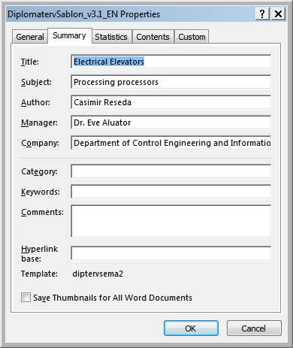

2.1. figure: Document properties dialog window

References

1. Levendovszky, J., Jereb, L., Elek, Zs., Vesztergombi, Gy.: Adaptive statistical algorithms in network reliability analysis, Performance Evaluation - Elsevier, Vol. 48, 2002, pp. 225-236
2. National Istruments: LabVIEW grafikus fejlesztői környezet leírása, <http://www.ni.com/> (2010. nov.)
3. Fowler, M.: UML Distilled, 3rd edition, ISBN 0-321-19368-7, Addison-Wesley, 2004
4. Wikipedia: Evaluation strategy, <http://en.wikipedia.org/wiki/Evaluation_strategy> (revision 18:11, 31 July 2012)

Annex